Ivan Cruz

Prof. Waziri

IT-520

April 3, 2018

Lab 6

1. The MAC address of my computer is 1c:1b:0d:43:33:5f
2. The destination MAC address is 20:c0:47:ba:fa:fe

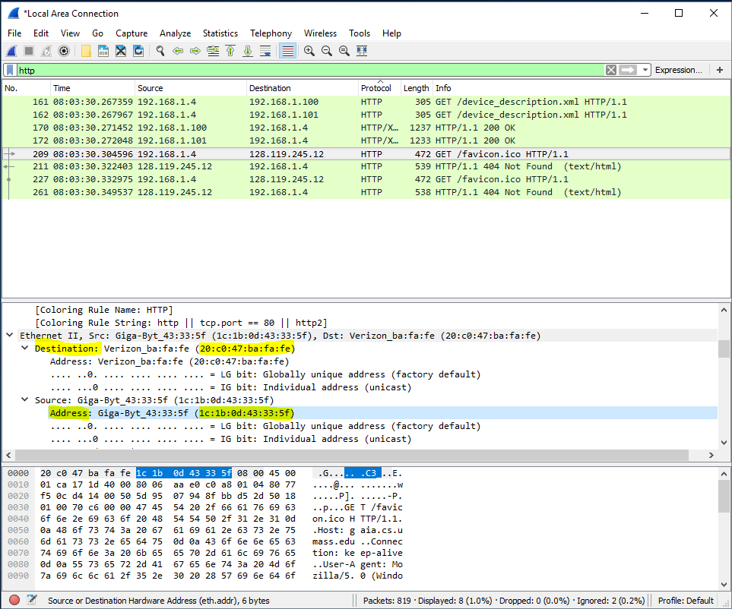

1. The destination device is the 1st hop router: my router
2. The sender knows the destination IP address but the MAC address is unknown, therefore the destination IP address is used to route and “ask” other routers for the MAC address of the specific destination.
3. I used the command *arp – a* to acquire the full list of my computer’s ARP table.

